*Covid Vaccination Information Tracker*

Abstract:

The Covid Vaccination Information Tracker Database is designed to keep track of available vaccination slots and the type of vaccine being administered. It also tracks the vaccination status of users, indicating whether they have taken dose 1, dose 2, or a booster shot.

The database can be used by healthcare providers, governments, and individuals to monitor the availability of vaccines and the vaccination status of their community or themselves. This information can be used to identify areas with low vaccination rates and target efforts to increase vaccination coverage.

Overall, the Covid Vaccination Information Tracker Database is an essential tool for managing the Covid-19 pandemic and ensuring that people receive the appropriate vaccinations to protect themselves and their communities.

ER Diagram:

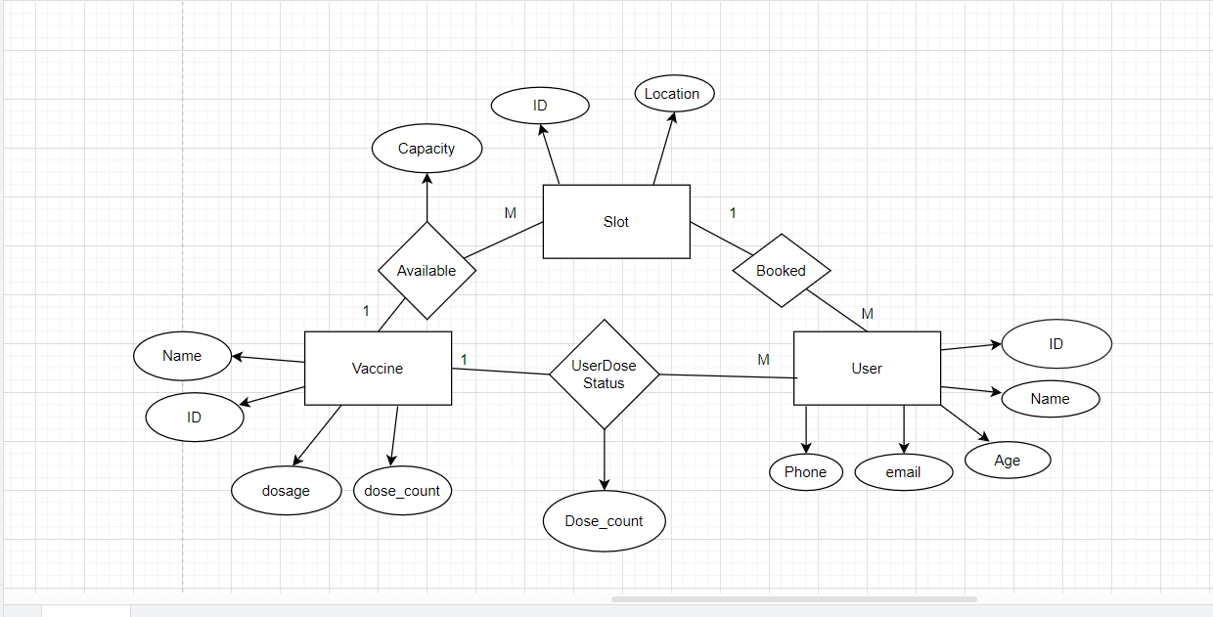

User_det Table:

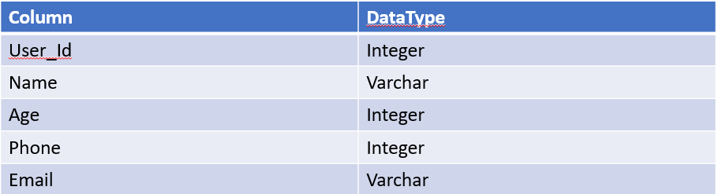

PrimaryKey: User_Id

Slot Table:

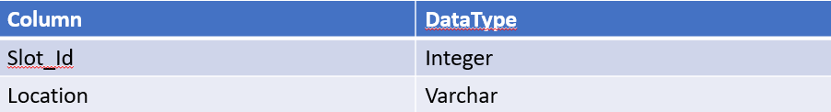

Primary Key: Slot_Id

Vaccine Table:

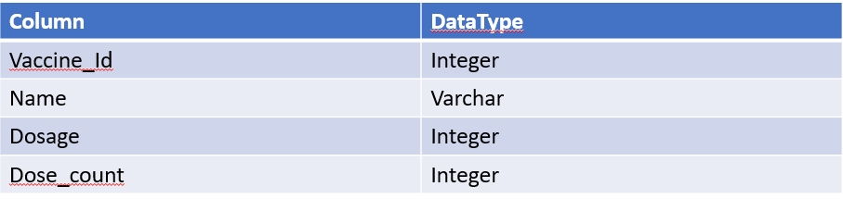

Primary Key:Vaccine_Id

Available Table:

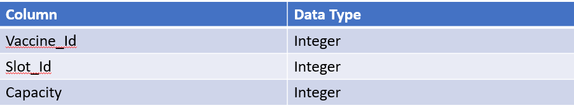

Foreign Key:Vaccine_id references Vaccine;

Foreign Key: Slot_Id references Slot;

primaryKey:Vaccine_id& Slot_Id

Booked Table:

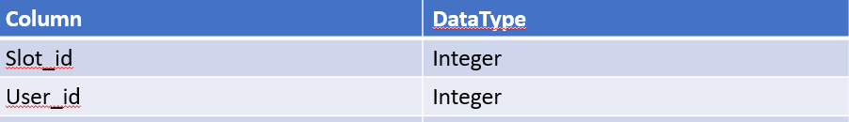

Foreign key: Slot_id references slot

Foreign key: User Id references slot

Primary Key: slot_id&user_id

UserDoseStatus Table:

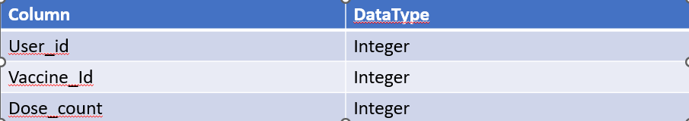

Foreign Key:User_id references user_det

Foreign key: Vaccine_id refences vaccine

Primary key:User_id & Vaccine_id

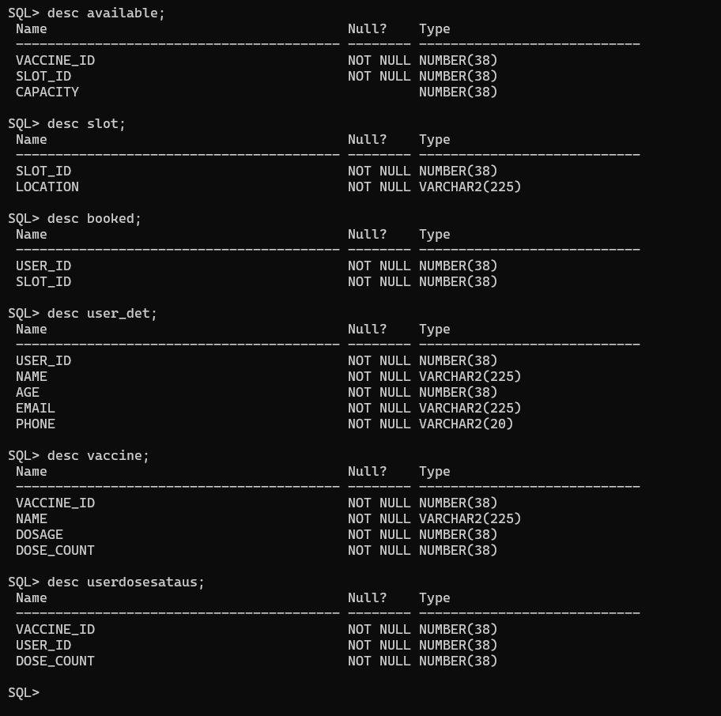

DDL Commands:



DML Commands:

